Report

Date | 18/09/2026
Team ID | MCA
Project Name | Smartphone Usage, Digital Addiction & Well-Being Analytics
Maximum Marks | 5 Marks

A report is a comprehensive document that provides a detailed and structured account of data analysis, findings, and insights. It is typically used for in-depth analysis, documentation, and communication of results. Reports are suitable for a diverse audience, including decision-makers, analysts, and stakeholders who need a comprehensive understanding of the data.
Designing a report in Power BI involves connecting to data sources, creating visualizations like charts and graphs, customizing their appearance and interactivity, organizing them logically on the canvas, formatting elements for consistency and clarity, and optionally creating dashboards for a summarized view. Throughout the process, it's essential to consider the audience's needs and ensure the report effectively communicates insights from the data. Finally, iterate based on feedback to continually improve the report's design and usefulness.

Report - 1
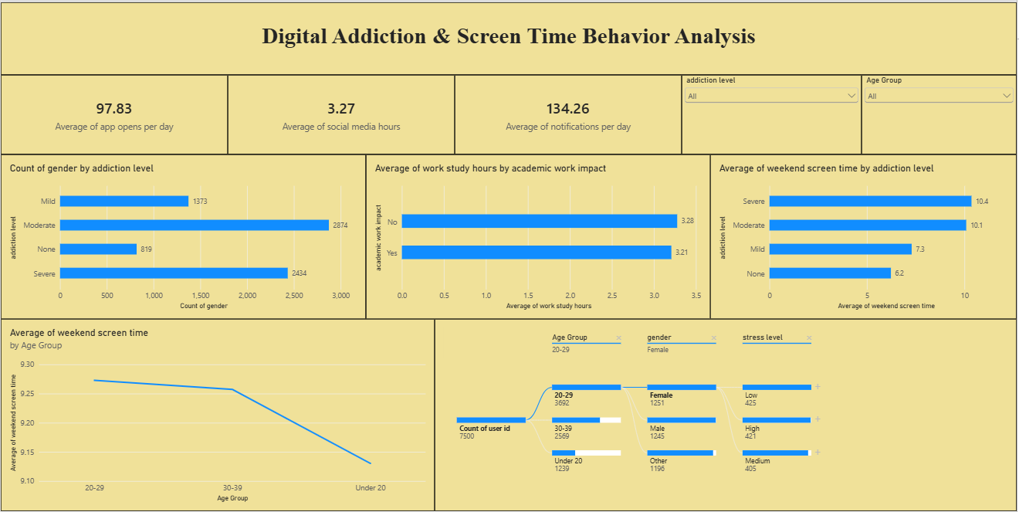
Observations drawn from reports in Power BI can provide valuable insights into business performance and trends.
1. Trends Over Time:
- Analyze how key metrics (e.g., sales, revenue, or customer counts) change over different time periods (monthly, quarterly, annually) to identify growth patterns or seasonality.
2. Performance Comparisons:
- Compare performance across different categories, such as regions, products, or departments, to determine which areas are excelling or underperforming.
3. Customer Segmentation:
- Assess demographic data (age, gender, location) to understand customer segments and tailor marketing strategies accordingly.

4. Goal Achievement:
- Measure progress against established KPIs (Key Performance Indicators) to assess whether business goals are being met.

Example:
1. Core Digital Engagement:
- Users interact heavily with their devices on a daily basis, logging a baseline average of 97.83 app opens per day alongside an average of 134.26 notifications received per day.
2. Prevalence of Addiction Levels:
- When evaluating the user base by categorical metrics, the Moderate group forms the largest share with 2,874 users, followed closely by the Severe group with 2,434 users.
3. Weekend Screen-Time Escalation:
- Users categorized with a Severe addiction level reach the highest weekend smartphone usage at an average of 10.4 hours, compared to 6.2 hours for those with no behavioral addiction.
4. Demographic Breakdown Path:
- Out of 7,500 total tracked users split through the decomposition tree, the largest segment is the 20–29 age group (3,692 users), within which Females represent the largest cohort (1,251 users).

Report - 2
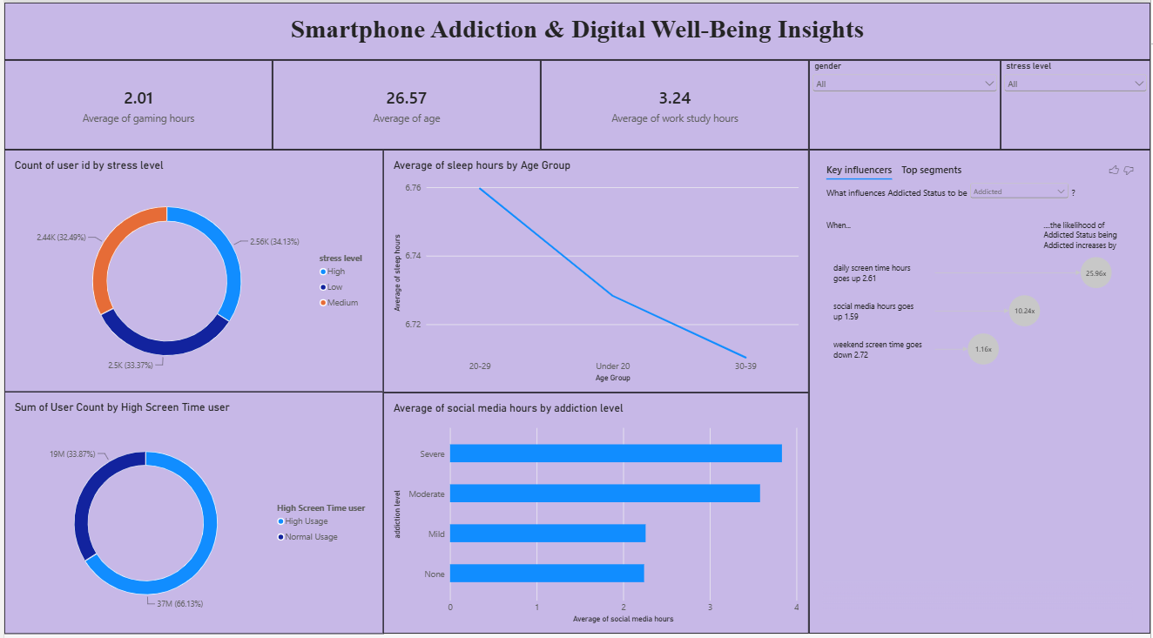

Observations drawn from reports in Power BI can provide valuable insights into business performance and trends.
1. Trends Over Time:
- Analyze how key metrics (e.g., sales, revenue, or customer counts) change over different time periods (monthly, quarterly, annually) to identify growth patterns or seasonality.
2. Performance Comparisons:
- Compare performance across different categories, such as regions, products, or departments, to determine which areas are excelling or underperforming.
3. Customer Segmentation:
- Assess demographic data (age, gender, location) to understand customer segments and tailor marketing strategies accordingly.
4. Goal Achievement:
- Measure progress against established KPIs (Key Performance Indicators) to assess whether business goals are being met.
Example:
1. Stress Level Distribution:
- The user base exhibits a relatively even breakdown across categories, where the High stress level cohort slightly leads the study at 34.13% (2.56K users).
2. Sleep Deficit Trends:
- Rest cycles drop consistently based on demographic brackets, with the 30–39 age group experiencing the lowest average rest profile at roughly 6.71 sleep hours.
3. Social Media Dependency:
- Users labeled with a Severe addiction level display the highest engagement metrics, logging nearly 4 hours of average social media platform runtime.
4. Key Behavioral Drivers (AI Insights):
- The Key Influencers analysis proves that a user's likelihood of being classified as addicted increases drastically by 25.96x when their daily screen time scales upward by 2.61 hours.

